LINUX Assignment

1. Create an empty file
2. Open it with VI editor

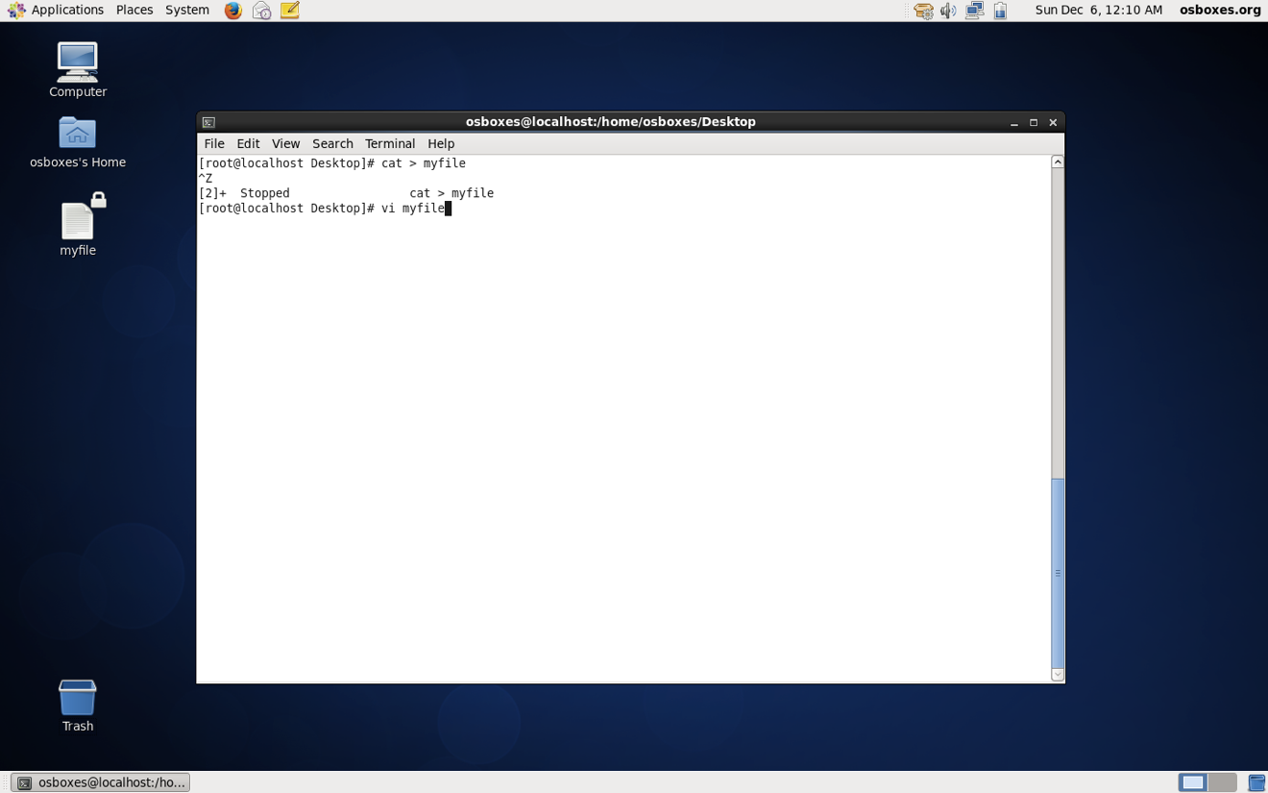

1. Write your name, address, email id, phone number and blood group in 5 different lines

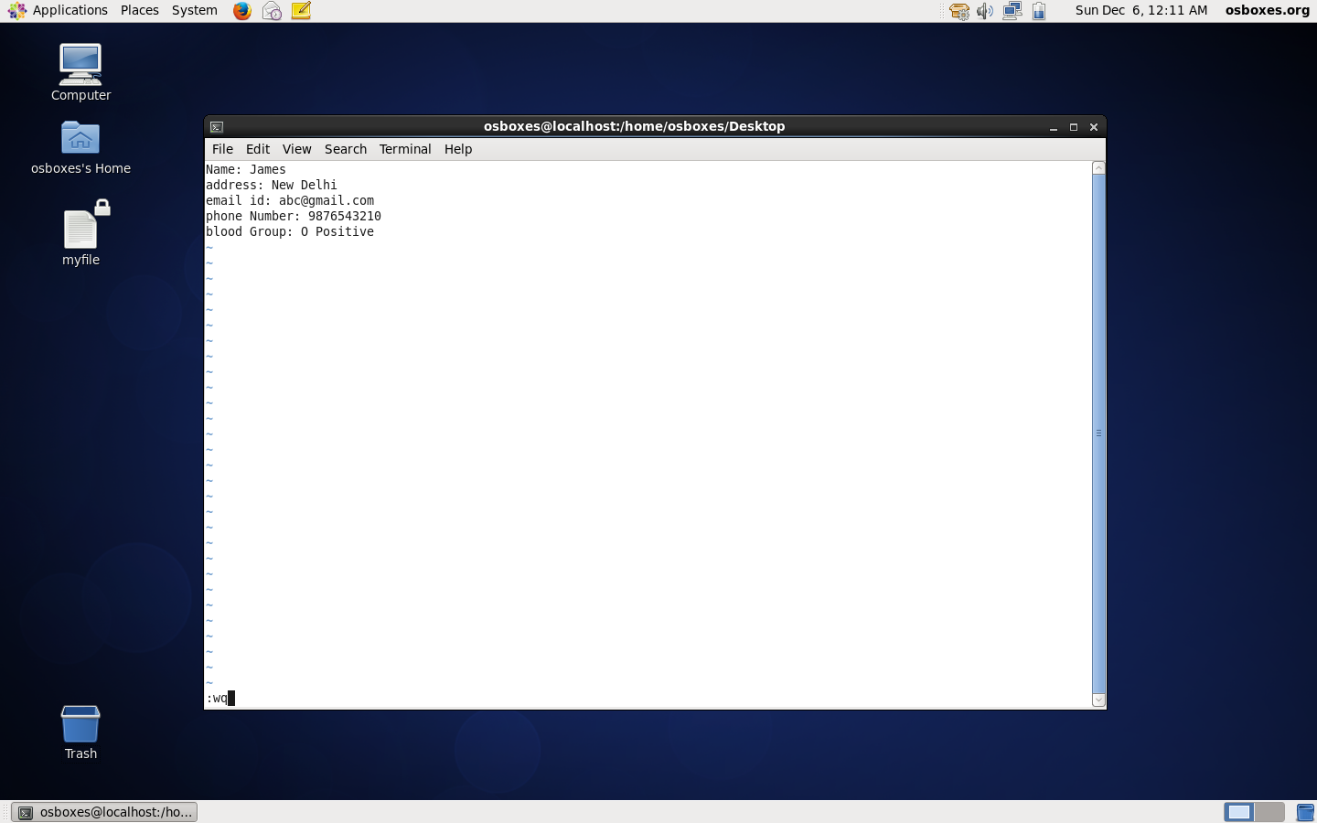

1. Build one single expression to see the line with your name and blood group in myfile

